

CSE6224 – Software Requirement Engineering

Campus Wellness Portal with

Medical System and Fitness Center

Integration Project – Part 1

Kano Model

Tutorial Section: TT6L

Group 4

|  |  |
| --- | --- |
| Group members | Student ID |
| Nicholas Thong Meng Shui | 241UC2415Y |
| Muhammad Anas bin Khairul Azman | 241UC2401Z |
| Fikrul Amsyar | 241UC24167 |

# Proof of Execution

## Observation (Existing Systems)

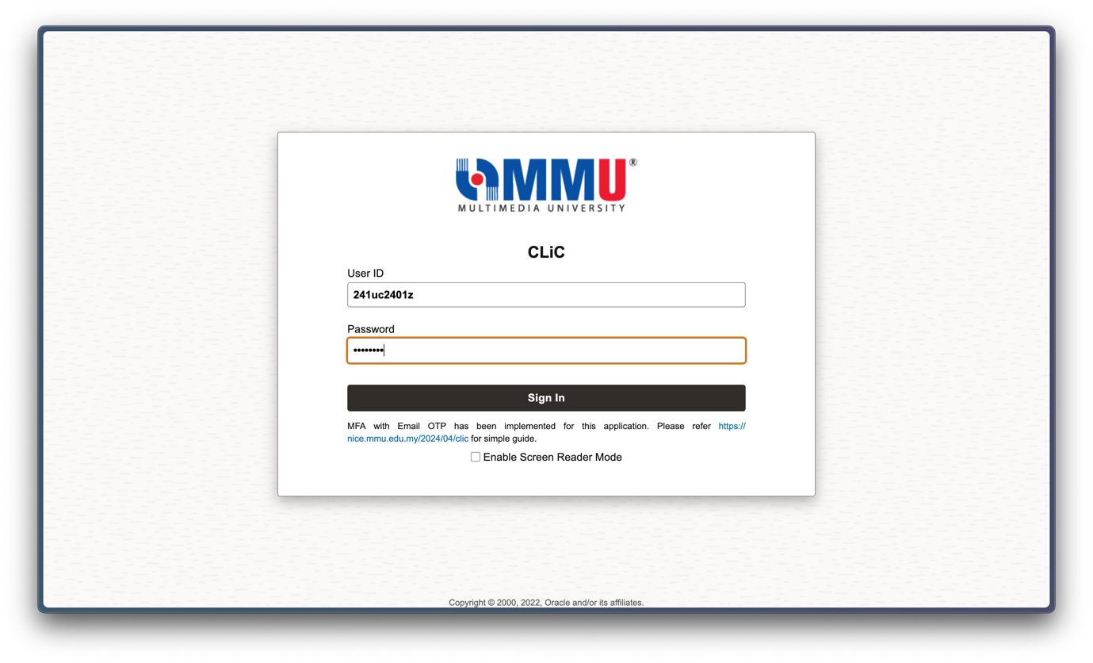

Figure : Login screen of MMU's CLiC system

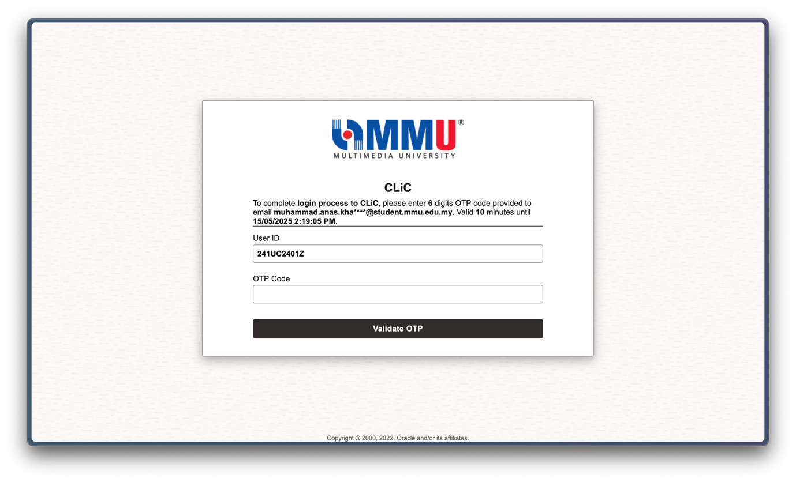

Figure : OTP authentication for CLiC login

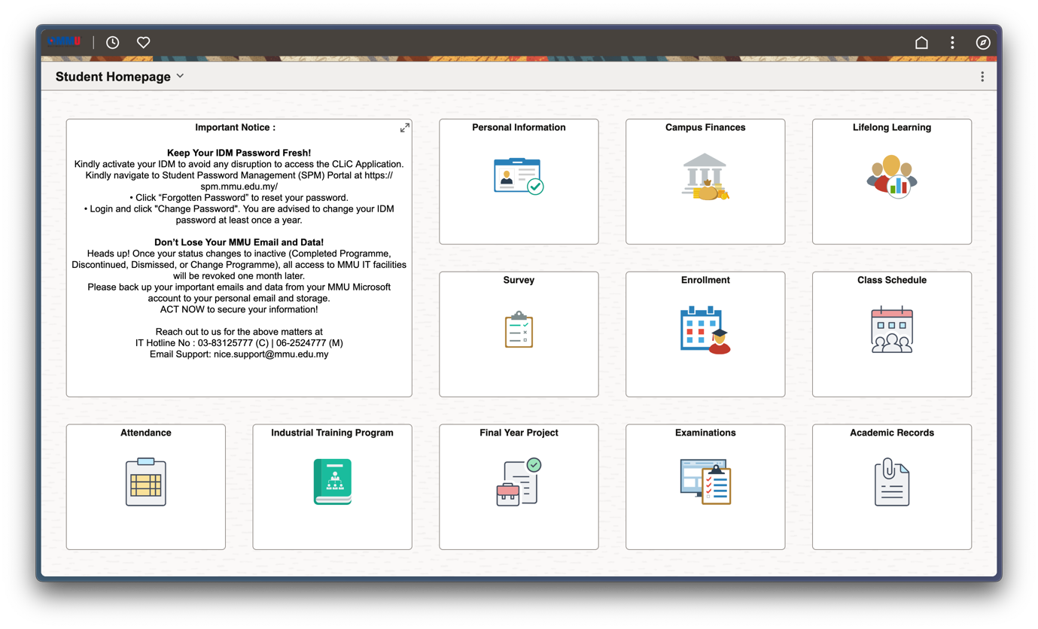

Figure : CLiC interface showing successful login

## Questionnaires

Google Form Link :  
<https://forms.gle/x1Vc84csHGJj5vzR7>

### Physical Questionnaire Proof:



Figure : Student answering physical questionnaire

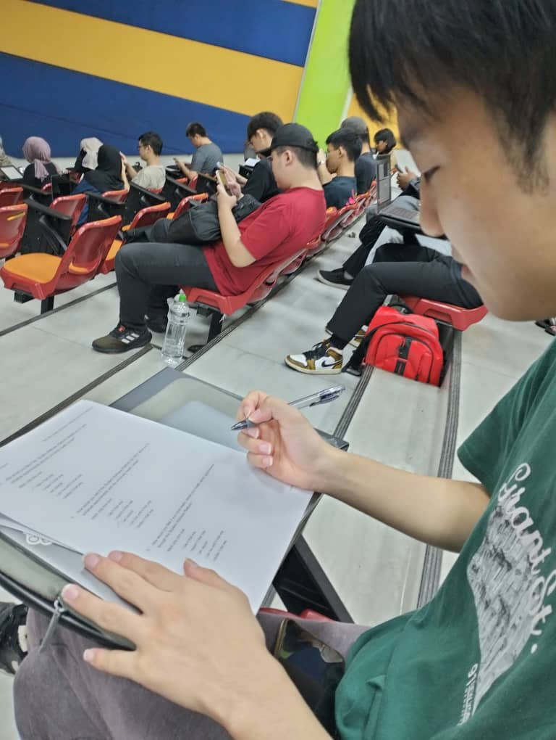

Figure : Student 2 answering physical questionnaire

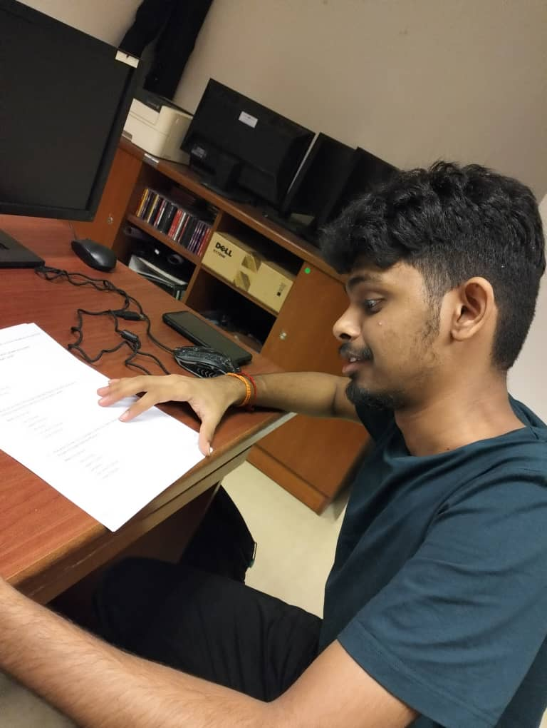

Figure : Student 3 answering physical questionnaire

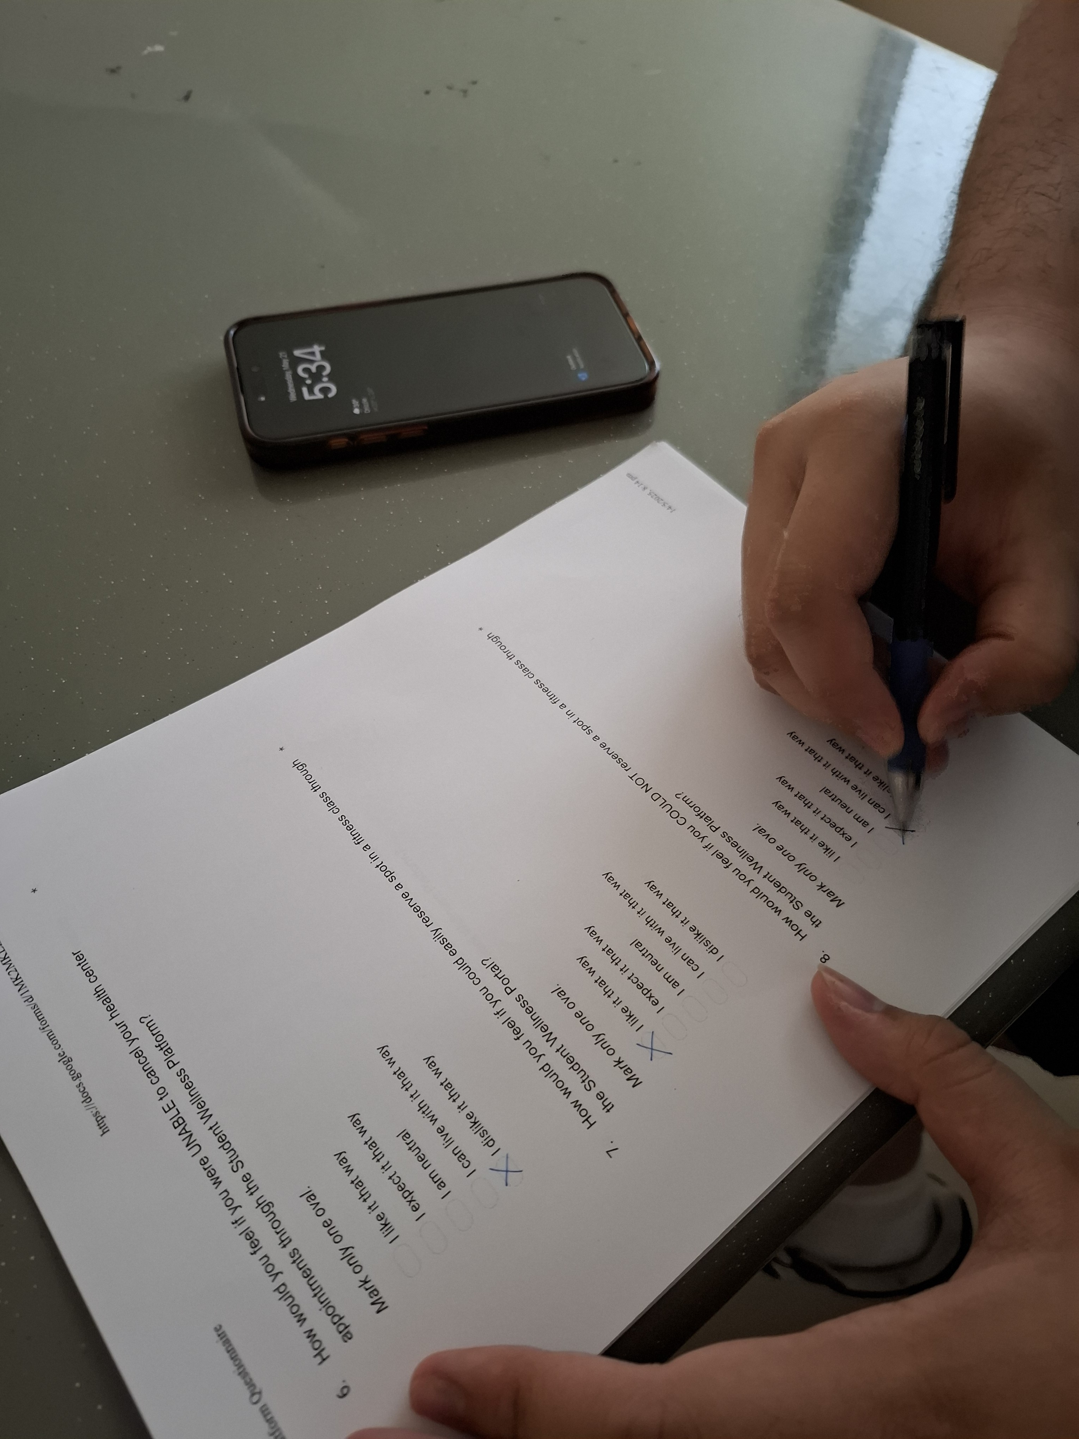

Figure : Student 4 answering physical questionnaire

### Online Questionnaire Proof:

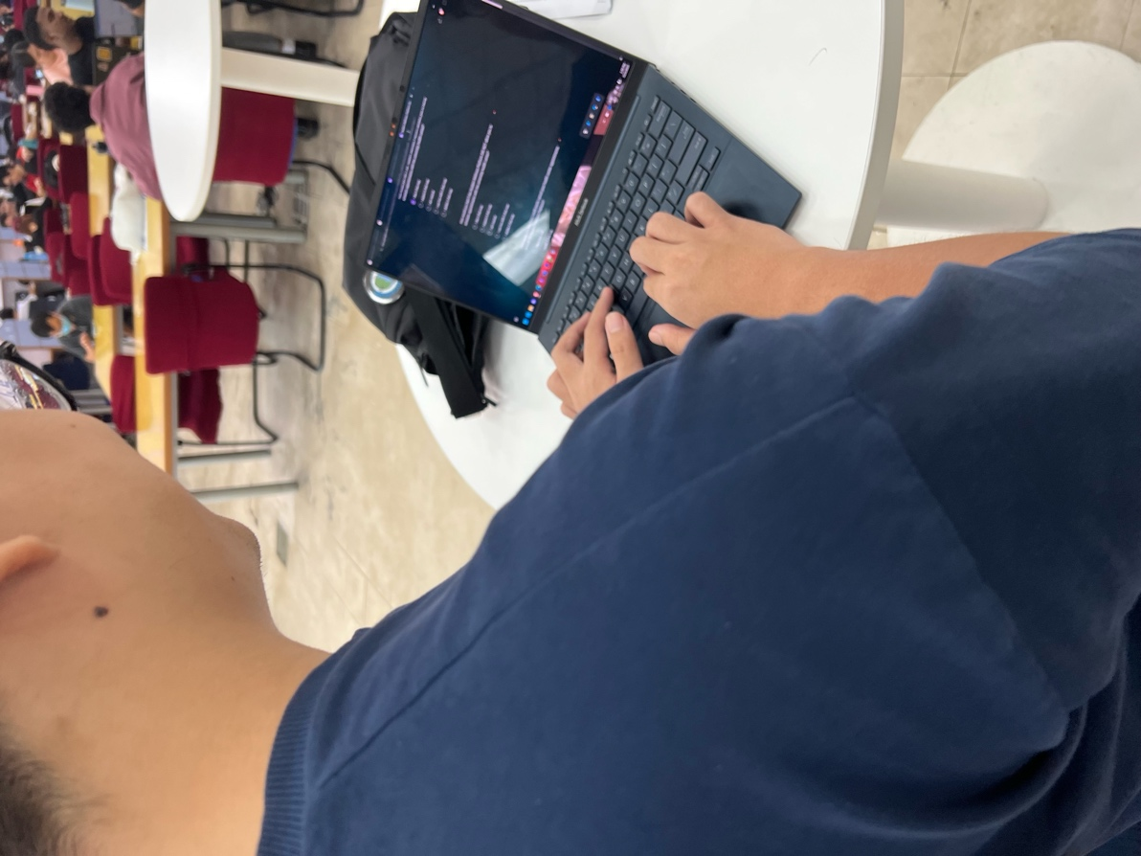

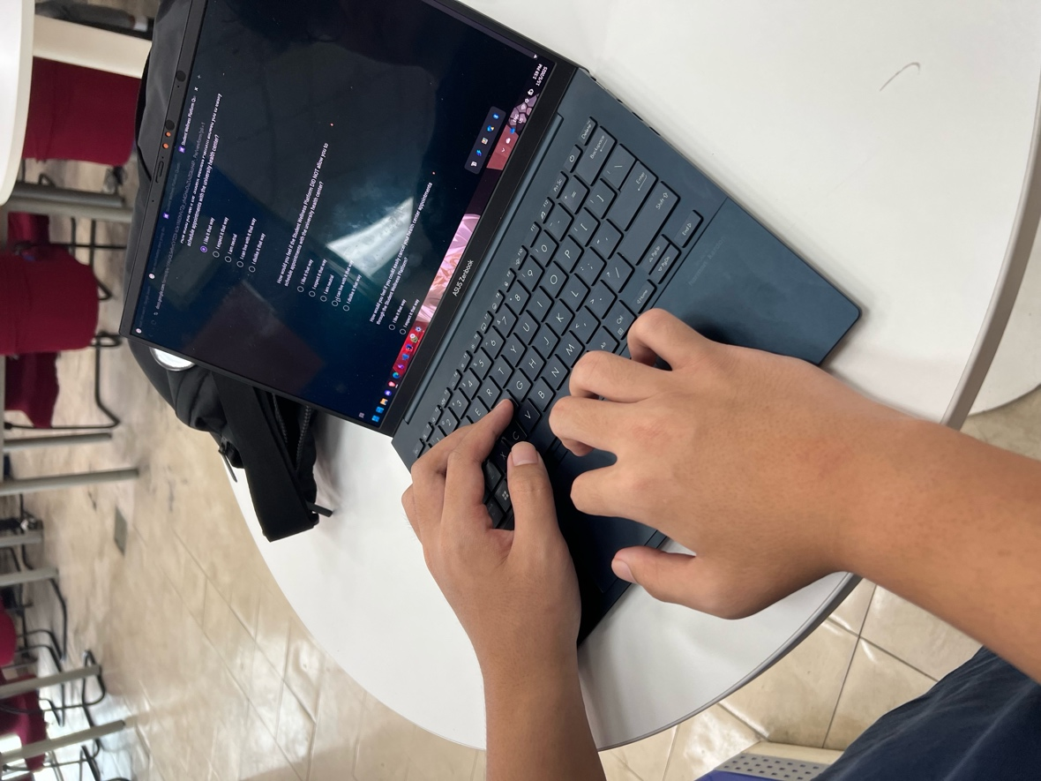

Figure : Student 1 answering online questionnaire

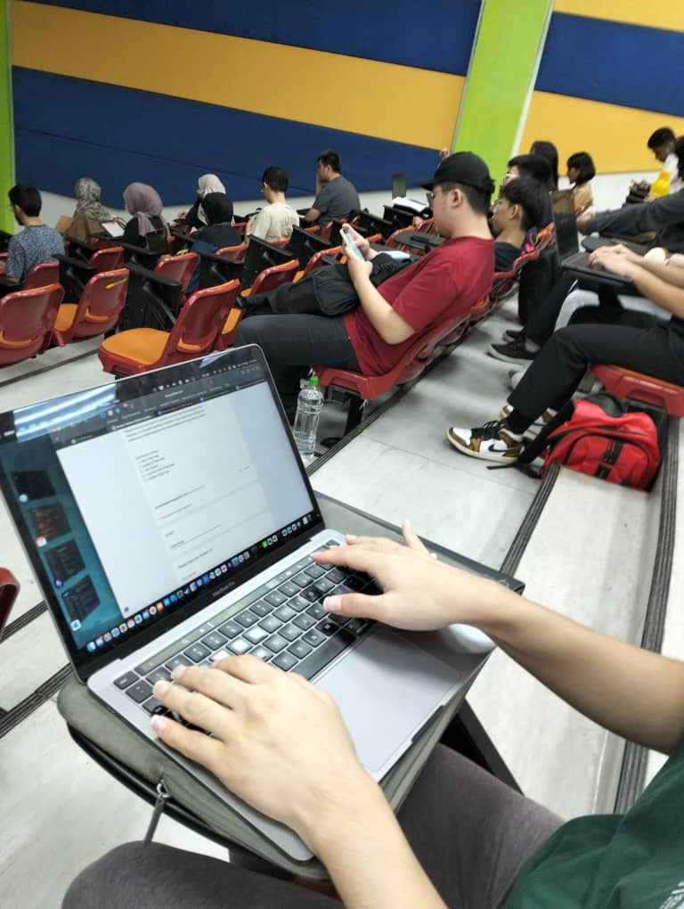

Figure : Student 2 answering online questionnaire

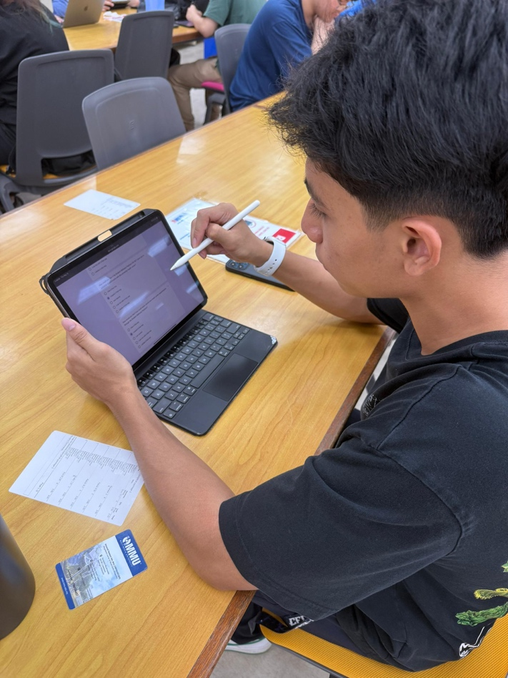

Figure 6: Student 3 answering online questionnaire

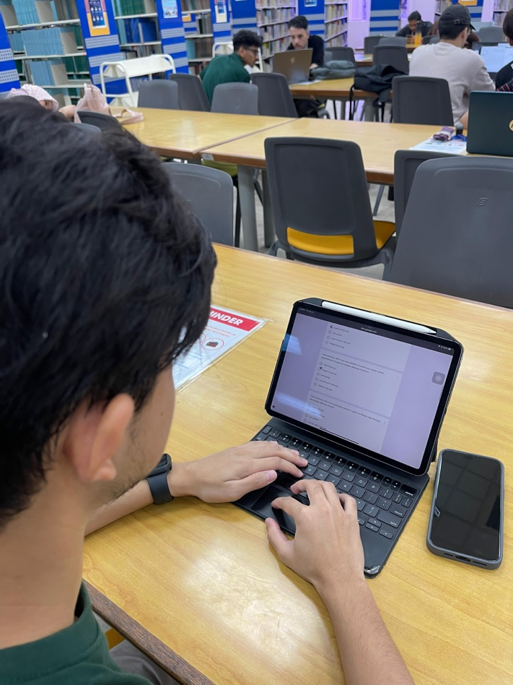

Figure : Student 4 answering online questionnaire

# Kano Model

## Kano Model Categories

* **Must-be features (high M)** indicate baseline expectations.
* **One-dimensional (O)** shows features where better implementation boosts satisfaction linearly.
* **Attractive (A)** are delighters.
* **Indifferent (I), Reverse (R), and Questionable (Q)** remain low or zero given clear user preferences.

**How Functional/Dysfunctional Questions are mapped to the Kano Model Categories:**

|  |  |  |  |  |  |
| --- | --- | --- | --- | --- | --- |
| **Dysfunctional ->** | **1: Like** | **2: Expect** | **3: Neutral** | **4: Can live with** | **5: Dislike** |
| **Functional**  |  v |
| **1: Like** | Q (Questionable) | A (Attractive) | A (Attractive) | I (Indifferent) | O(One-Dimensional) |
| **2: Expect** | A (Attractive) | I (Indifferent) | I (Indifferent) | I (Indifferent) | M (Must-be) |
| **3: Neutral** | A (Attractive) | I (Indifferent) | I (Indifferent) | I (Indifferent) | M (Must-be) |
| **4: Can live with** | I (Indifferent) | I (Indifferent) | I (Indifferent) | I (Indifferent) | M (Must-be) |
| **5: Dislike** | R (Reverse) | R (Reverse) | R (Reverse) | R (Reverse) | Q (Questionable) |

## Questionnaire Responses Tallied

Below is the table showing the questionnaire responses tallied according to the Kano Model Categories above:

|  |  |  |  |  |  |
| --- | --- | --- | --- | --- | --- |
| **Question** | **1** | **2** | **3** | **4** | **5** |
| 1. How would you feel if the platform allowed you to easily schedule health-center appts? | 1 | 18 | 1 | 0 | 0 |
| 2. How would you feel if the platform DID NOT allow you to schedule health-center appts? | 0 | 1 | 1 | 1 | 17 |
| 3. How would you feel if you could easily cancel your health-center appointments? | 0 | 6 | 14 | 0 | 0 |
| 4. How would you feel if you were UNABLE to cancel your health-center appointments? | 0 | 4 | 3 | 1 | 12 |
| 5. How would you feel if you could easily reserve a spot in a fitness class? | 0 | 2 | 18 | 0 | 0 |
| 6. How would you feel if you COULD NOT reserve a spot in a fitness class? | 0 | 3 | 1 | 1 | 15 |
| 7. How would you feel if you could easily cancel your fitness-class reservation? | 3 | 6 | 11 | 0 | 0 |
| 8. How would you feel if you were UNABLE to cancel your fitness-class reservation? | 0 | 0 | 3 | 7 | 10 |
| 9. How would you feel if the platform allowed you to track your wellness goals? | 16 | 4 | 0 | 0 | 0 |
| 10. How would you feel if the platform DID NOT provide any way to track your wellness goals? | 0 | 4 | 1 | 1 | 14 |
| 11. How would you feel if you received real-time notifications about fitness-class bookings? | 4 | 6 | 8 | 1 | 1 |
| 12. How would you feel if you DID NOT receive real-time notifications about fitness-class bookings? | 10 | 5 | 0 | 3 | 2 |
| 13. How would you feel if you received real-time notifications about your health appointments? | 4 | 8 | 7 | 1 | 0 |
| 14. How would you feel if you DID NOT receive real-time notifications about your health appointments? | 10 | 0 | 4 | 4 | 2 |
| 15. How would you feel if the platform provided personalized health tips or recommendations? | 4 | 5 | 7 | 3 | 1 |
| 16. How would you feel if the platform did NOT offer any personalized health tips or recommendations? | 7 | 4 | 6 | 0 | 3 |
| 17. How would you feel if the Student Wellness Platform allowed you to see your scheduled health centre appointments? | 16 | 4 | 0 | 0 | 0 |
| 18. How would you feel if the Student Wellness Platform DID NOT allow you to see your scheduled health centre appointments? | 0 | 4 | 1 | 1 | 14 |
| 19. How would you feel if the Student Wellness Platform allowed you to see your scheduled fitness classes? | 16 | 4 | 0 | 0 | 0 |
| 20. How would you feel if the Student Wellness Platform DID NOT allow you to see your scheduled fitness classes? | 0 | 4 | 2 | 0 | 14 |

## Finalised Requirements Classification using Kano Model

|  |  |
| --- | --- |
| **Dissatisfiers** | **Requirement ID** |
| User authentication | REQID_01 |
| Health centre appointment scheduling | REQID_02 |
| Health centre appointment cancellation | REQID_03 |
| Fitness class reservation booking | REQID_04 |
| Fitness class reservation cancellation | REQID_05 |

|  |  |
| --- | --- |
| **Satisfiers** | **Requirement ID** |
| Student wellness tracking goals | REQID_06 |
| Development time constraints | REQID_07 |
| View Scheduled Health Appointments | REQID_08 |
| View Scheduled Fitness Classes | REQID_09 |
| **Delighters** | **Requirement ID** |
| Real-time fitness class notifications | REQID_10 |
| Real-time medical appointment updates | REQID_11 |
| Personalized health recommendations | REQID_12 |